**Store Manager: Keep Track of Inventory**

**(React Application)**

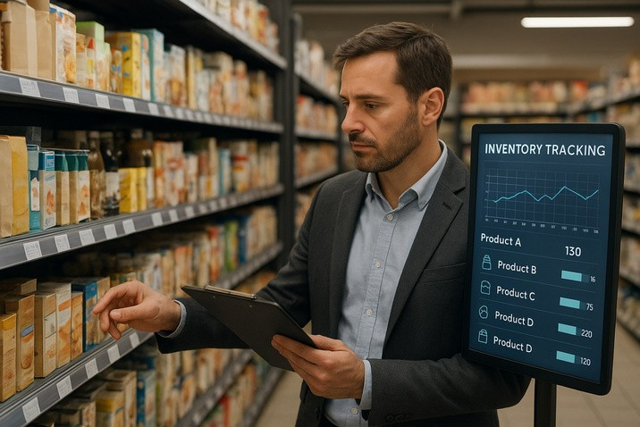

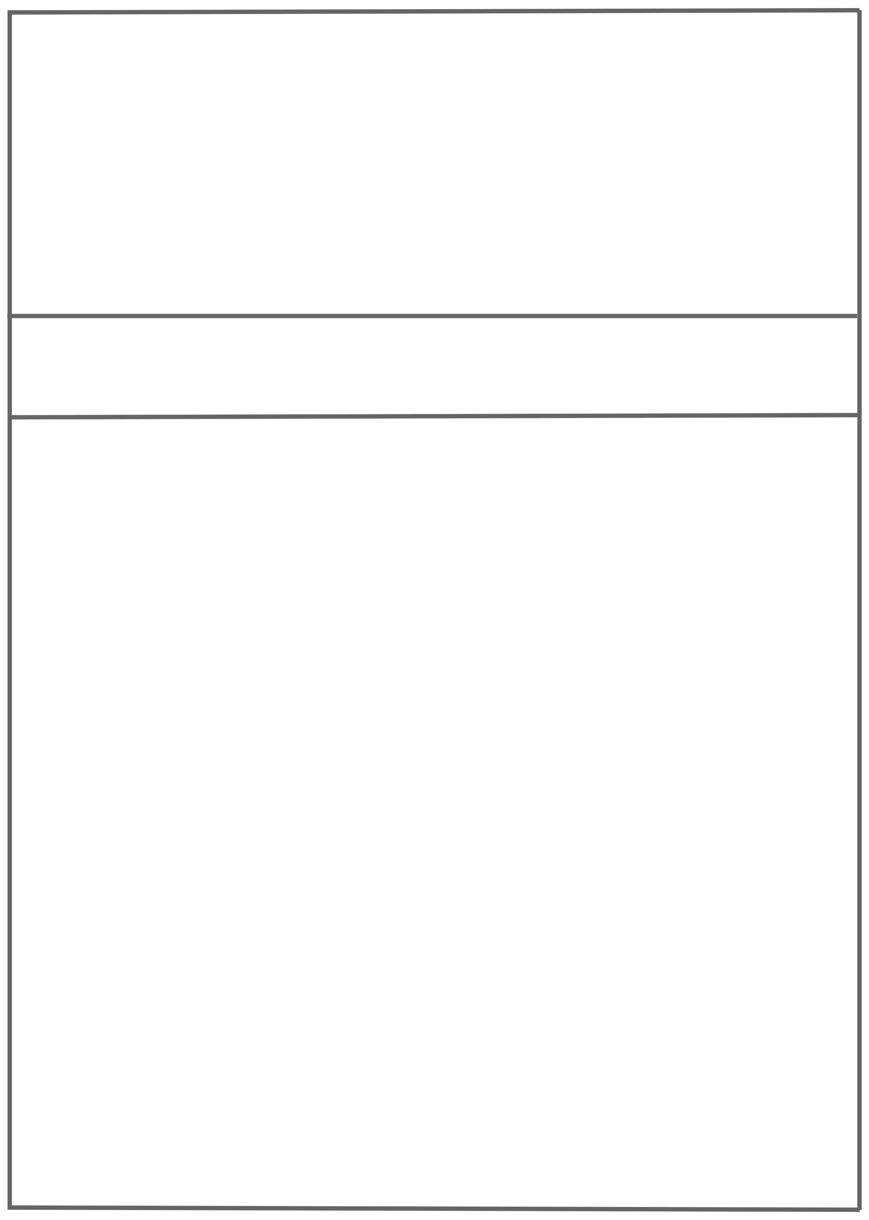

GOVERNMENT ARTS AND SCIENCE COLLEGE

19, POONTHOTTAM STREET

THIRUVOTTIYUR ,CHENNAI-19

Store Manager: Keep Track Of Inventory

Team ID: NM2025TMID37748

Team Size: 5

Team Leader: SYAM SUNDAR L Team Member: VALLARASU B

Team Member: VASANTHAKUMAR R Team Member: VIGNESH M Team Member: YUVANESH S

INDEX

* INTRODUCTION
* DESCRIPTION
* KEY FEATURES
* PRE-REQUISITES
* PROJECT FLOW
* PROJECT STRUCTURE
* PROJECT SETUP AND CONFIGURATION
* PROJECT DEVELOPMENT
* PROJECT IMPLEMENTATION & EXECUTION

# Introduction:

In today’s competitive retail landscape, efficient inventory management is critical to a store’s success. A Store Manager Inventory Systemis a digital solution designed to help businesses monitor, control, and optimize their stock levels in real-time. Whether managing a small boutique or a large warehouse, store managers need visibility and control over inventory to reduce waste, prevent stockouts or overstocking, and increase operational efficiency.

# Description:

The **Store Manager: Keep Track of Inventory** system is a centralized platform that enables store owners and managers to:

* Add, update, and delete product details.
* Monitor stock levels in real time.
* Set alerts for low-stock items.
* Track incoming shipments and outgoing sales.
* Generate reports on inventory status and trends.
* Integrate with sales systems (POS) and suppliers.

This system streamlines the stock management process and provides valuable insights to make data-driven decisions, improving customer satisfaction and profitability.

# Key Features:

 **Inventory Management:** Inventory Management helps maintain healthy stock levels in a store and acquire them in time.

 **Stock Updates:** Stock will automatically update on sale of products, and it can be updated on adding new stock.

 **Cart:** Products can be added to cart for a particular sale and quantity can be added to each product.

 **Checkout at Cart**: Upon checkout, cart is cleared, inventory is updated, and a sale record is made.

 **Adding New Products to Inventory:** New products can be added to the inventory by providing product name, image URL, price, stock, tags.

 **Alert View for Depleting Stock:** Depleting stocks are shown in red background, and alert count can be updated as per requirement.

 **Search Functionality for Products:** Products in inventory and product catalog can be searched.

**Sale Records:** All sale records are stored with sale value, products and datetime.

# PRE-REQUISITES:

Here are the key prerequisites for developing a frontend application using React.js:

## Node.js and npm:

Node.js is a powerful JavaScript runtime environment that allows you to run JavaScript code on the local environment. It provides a scalable and efficient platform for building network applications.

* 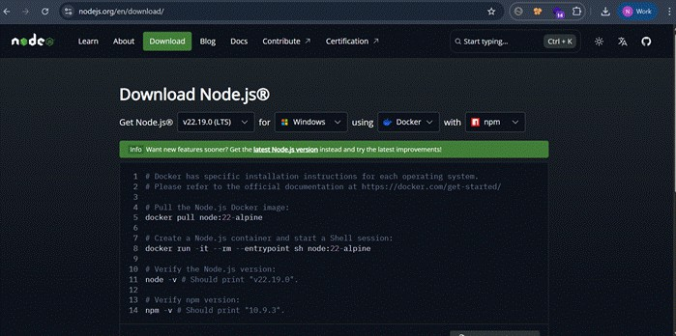Download **Node.js LTS version** from <https://nodejs.org/en/download/>
* Select your system configuration and click on
  + **Windows installer (.msi)** if windows

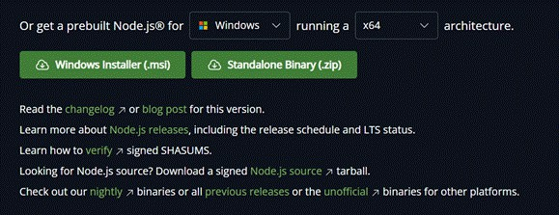

* After downloading, install Node.js by opening the downloaded file and follow the instructions below.

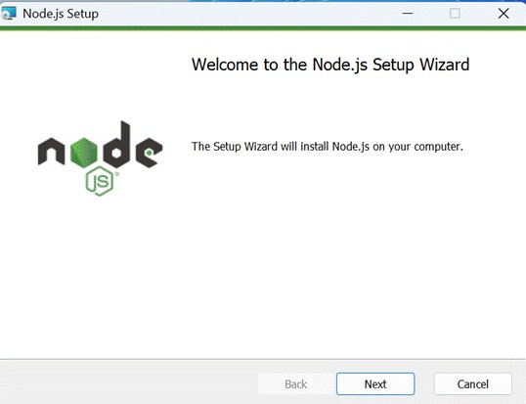

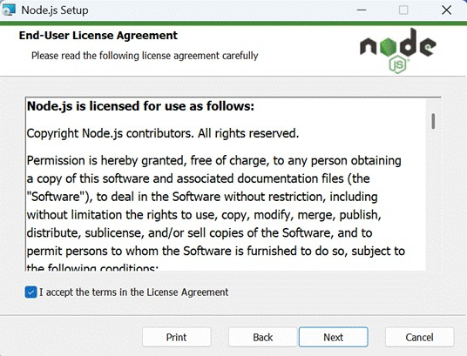

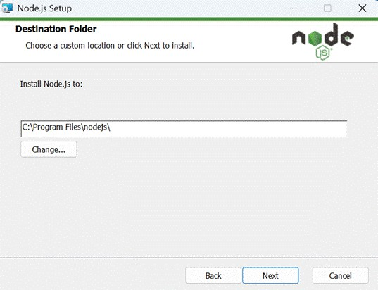

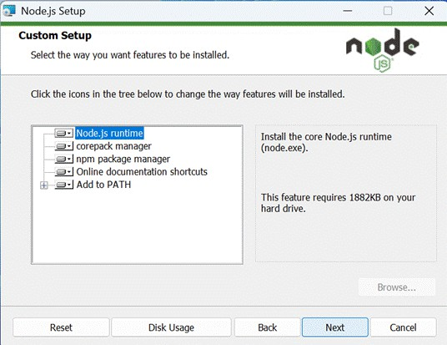

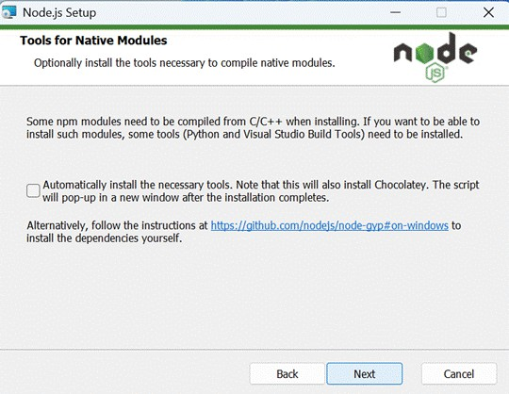

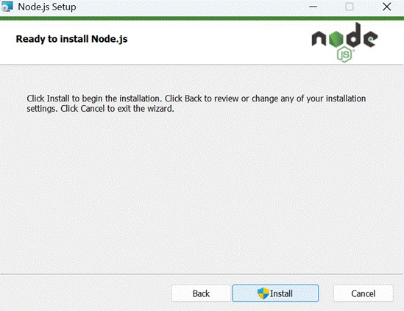

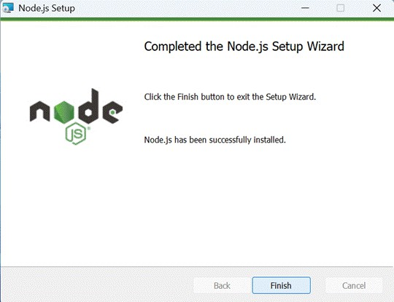

* After installing Node.js, open **Windows PowerShell As Administrator**

Type **set-executionPolicy unrestricted** and press enter

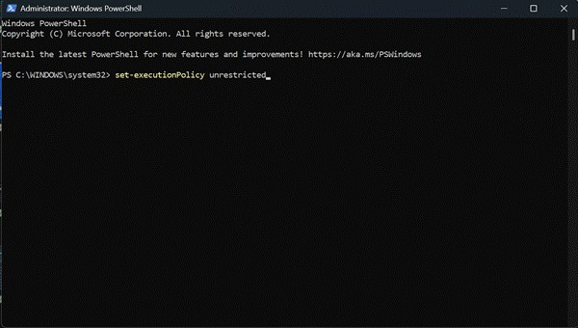

* In the next step type **Y** and press enter.

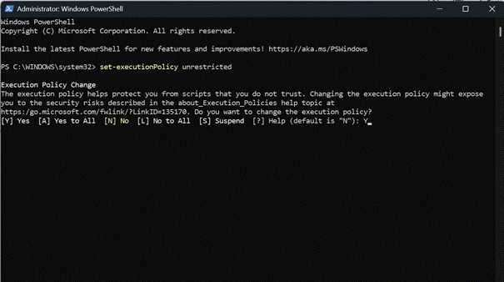

## React.js:

React.js is a popular JavaScript library for building user interfaces. It enables developers to create interactive and reusable UI components, making it easier to build dynamic and responsive web applications.

Install React.js, a JavaScript library for building user interfaces.

 **Create a new React app*:*** *npx create-react-app my-react-app*

Replace my-react-app with your preferred project name.

 **Navigate to the project directory*:*** *cd my-react-app*

## Running the React App:

With the React app created, you can now start the development server and see your React application in action.

 **Start the development server:** *npm start*

This command launches the development server, and you can access your React app at [http://localhost:3000](http://localhost:3000/) in your web browser.

 **HTML, CSS, and JavaScript:** Basic knowledge of HTML for creating the structure of your app, CSS for styling, and JavaScript for client-side interactivity is essential.

 **Version Control:** Use Git for version control, enabling collaboration and tracking changes throughout the development process. Platforms like GitHub or Bitbucket can host your repository.

* **Git: Download and installation instructions can be found at:** <https://git-scm.com/downloads>

 **Development Environment**: Choose a code editor or Integrated Development Environment (IDE) that suits your preferences, such as Visual Studio Code, Sublime Text, or WebStorm.

* **Visual Studio Code:** Download from <https://code.visualstudio.com/download>
* **Sublime Text:** Download from <https://www.sublimetext.com/download>
* **WebStorm:** Download from [https://www.jetbrains.com/webstorm/download](https://www.jetbrains.com/webstorm/download%20)

# Project Flow:

### Demo Link :

<https://drive.google.com/file/d/1i_BNxMjY5DM2irPCnzyKCRlwqlKn7d/view?usp=sharing>

### Code Reference :

<https://drive.google.com/drive/folders/1BPYYmXEAEmpDlvCQnz5HDGmhXloYzJ5c?usp=sharing>

**To get the Application project from drive:**

* Download the inventory-management-frontend folder.

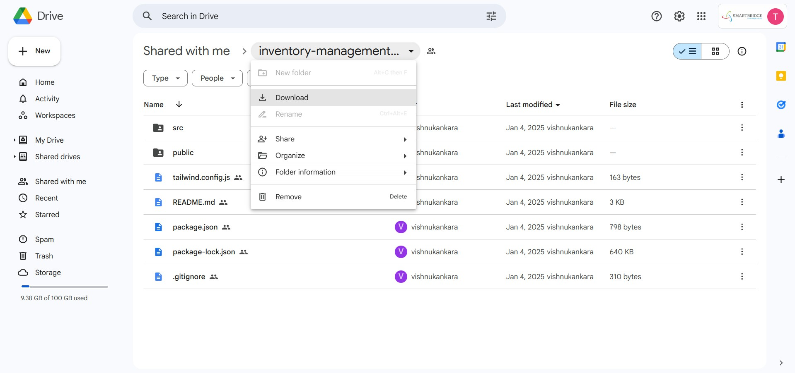

* Now go to downloads and **right click** on the downloaded zip folder and click on **extract all.**

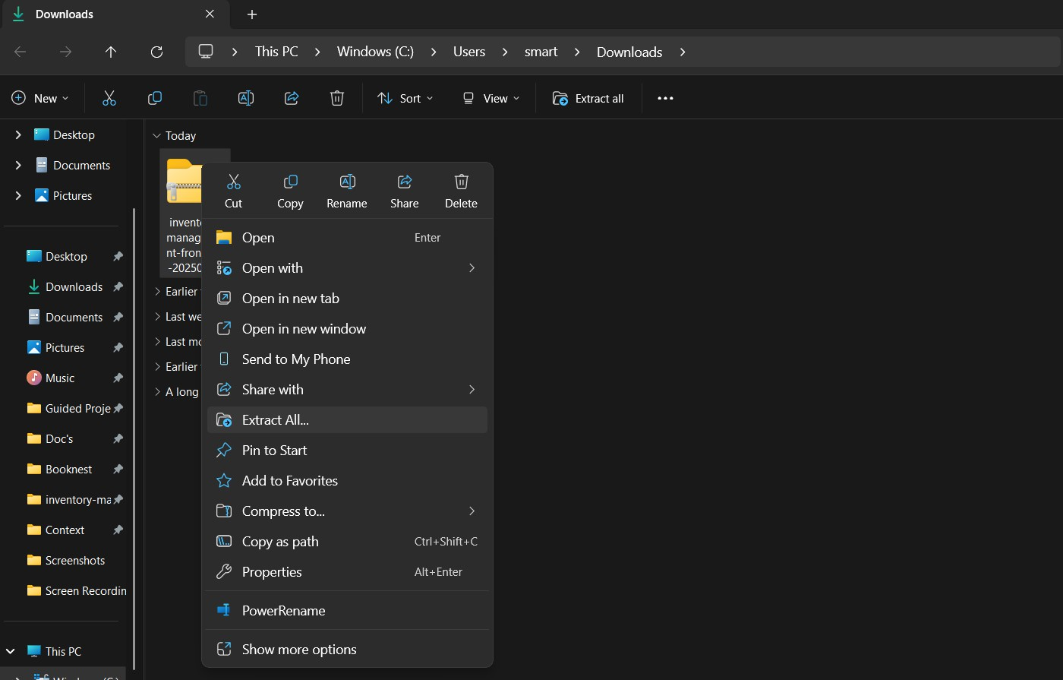

* Now click on **Extract All**
* Now open VS code and open the **inventory-management-frontend** folder from the **extracted folder**.

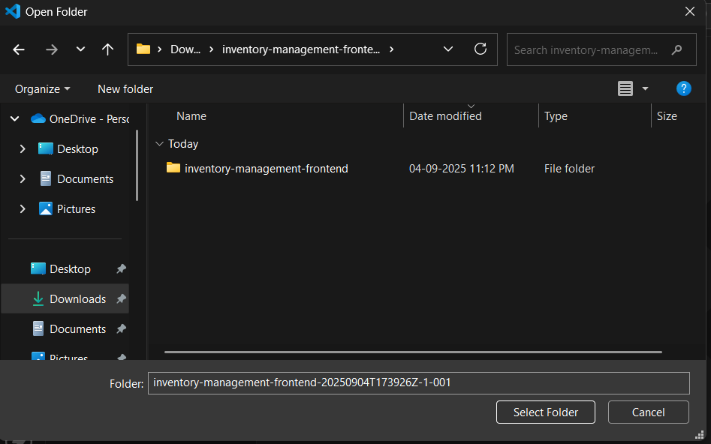

# Now open a project structure.

# Project structure:

The image is of the folder structure which shows all the files and folders that have been used in project development.

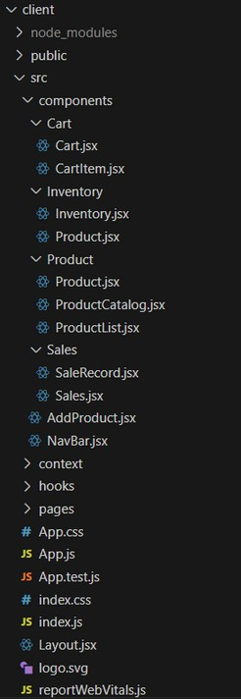

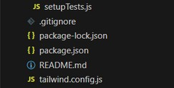

* In this project, we’ve split the files into 3 major folders, **Components**, **Pages and Styles**.
* In the pages folder, we store the files that acts as pages at different url’s in the application.
* The components folder stores all the files, that returns the small components in the application.
* All the styling css files will be stored in the styles folder.

# Project setup and configuration:

## Project Setup:

### Step 1: Initialize a new React application.

* Use create-react-app or Vite for project setup.

### Step 2: Install dependencies.

* Add tailwindcss, react, react-dom, and other necessary packages.

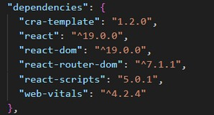

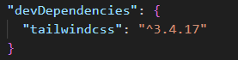

### Step 3: Configure TailwindCSS.

* Set up the tailwind.config.js file.
* Add the required styles in index.css.

### Step 4: Create a basic folder structure.

* **Example:**

**css**

**src/**

**??? components/**

**??? context/**

**??? hooks/**

**??? pages/**

* **For further reference, use the following resources**
* <https://react.dev/learn/installation>
* <https://react-bootstrap-v4.netlify.app/getting-started/introduction/>
* <https://axios-http.com/docs/intro>
* <https://reactrouter.com/en/main/start/tutorial>

# Project Development:

### Setting Up Context and Reducers

 **Step 1: Create context files for Inventory, Cart, and Sales.**

 Use createContext() and define default states.

### Step 2: Define reducers for state management.

 Inventory Reducer: Handle stock addition, updates, and sales.

 Cart Reducer: Manage adding/removing items and quantities.

 Sales Reducer: Track sales records.

### Step 3: Set up ContextProvider components.

 Wrap the app in these providers in index.js or App.js.

### Step 4: Persist data in localStorage.

 Save and load context states to/from localStorage.

### Milestone 3 - Developing Core Components

**Step 1: Build the Inventory Component.**

* + Display a list of products with stock details.
  + Implement search and alert value input.

### Step 2: Build the Product Component.

* + Show product details, including an image, price, and stock.
  + Add functionality to update stock.

### Step 3: Build the Cart Component.

 Display items added to the cart with quantity and total value.

 Add buttons for incrementing, decrementing, and removing items.

 Include checkout functionality to update inventory and create sales records.

### Step 4: Build the Sales Component.

 Display a list of sales records with details like date, cart items, and total sale value.

 Sort records from the latest to the oldest.

**Milestone 4 - Implementing Utilities**

**Step 1: Create reusable helper functions.**

* + Format currency.
  + Sort or filter data.

**Step 2: Add input validation.**

* + Prevent invalid values for stock or cart quantities.

**Step 3: Handle edge cases.**

* + Avoid negative stock updates.
  + Restrict checkout when the cart is empty.

### Milestone 5 - Styling with TailwindCSS

**Step 1: Create responsive layouts.**

 Use flexbox (flex, flex-wrap) and grid utilities.

### Step 2: Style individual components.

 Inventory: Add hover effects and responsive search bar.

 Cart: Highlight selected products and display alerts on low stock.

 Sales: Use a clean table or card layout for sale records.

### Step 3: Ensure consistency.

 Apply a theme or consistent color palette.

**Milestone 6 - Testing and Debugging**

**Step 1: Test individual components.**

 Ensure correct rendering and functionality.

### Step 2: Test context and reducers.

 Verify state updates and interactions with localStorage.

### Step 3: Debug UI/UX issues.

* Check for responsiveness and usability.
* **Finally,**
* Now open a new terminal

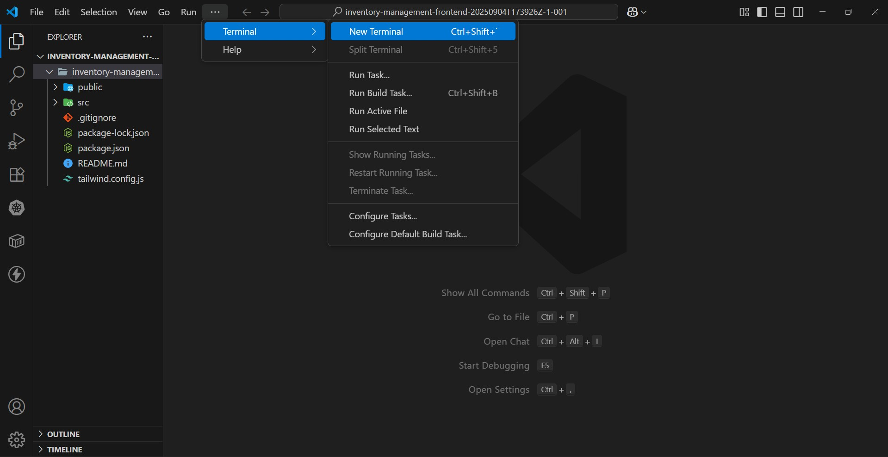

**Follow below steps:**

**Install Dependencies:**

Type **npm install** in your terminal and press **Enter** and wait till all the dependencies gets download.

### Navigate into the cloned repository directory and install libraries:

### *cd inventory-management-frontend*

### *npm install*

### 

## Start the Development Server:

### To start the development server, execute the following command:

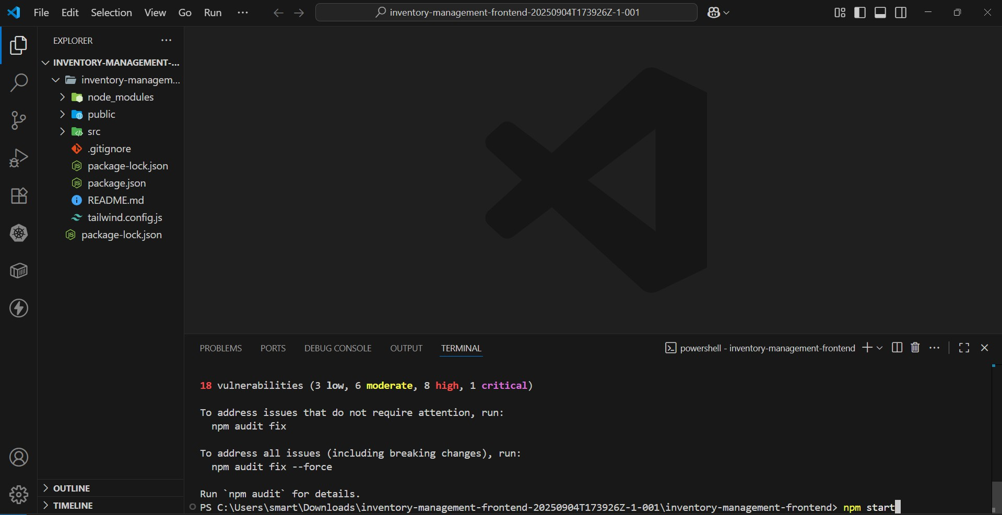 *npm start*

## Access the App:

Now your application will be opened in your browser with url [http://localhost:3000](http://localhost:3000/)

* Open your web browser and navigate to [http://localhost:3000](http://localhost:3000/).
* You should see the application's homepage, indicating that the installation and setup were successful.
* You have successfully installed and set up the application on your local machine.
* You can now proceed with further customization, development, and testing as needed.

# Project Implementation & Execution:

**Product Catalog:**

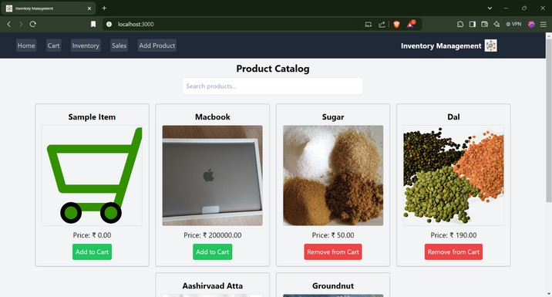

**Cart:**

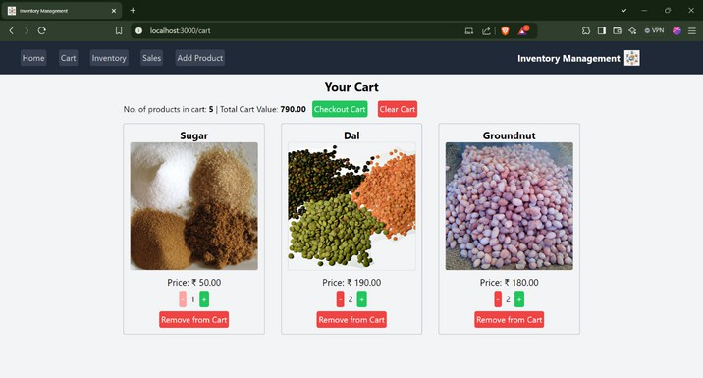

**Inventory:**

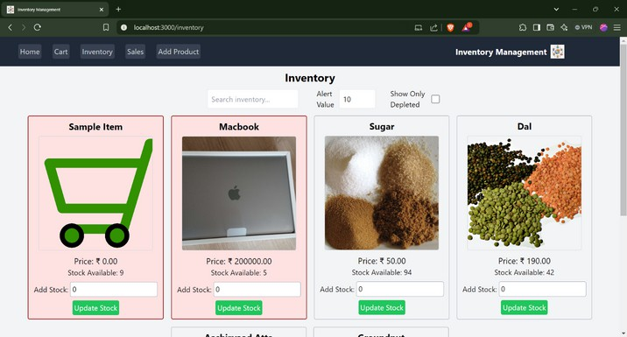

**Depleted Stock:**

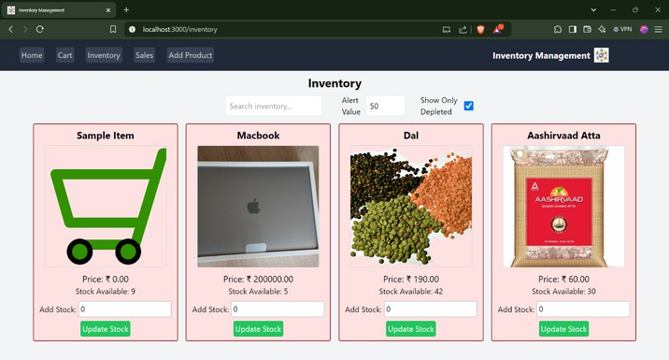

**Search Functionality:**

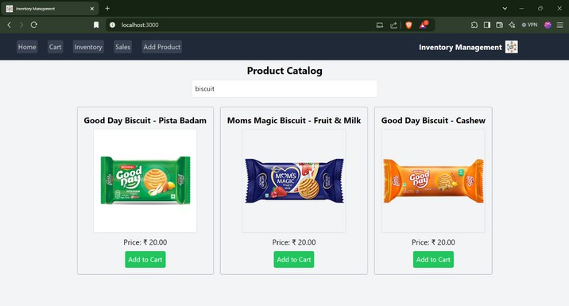

**Sales:**

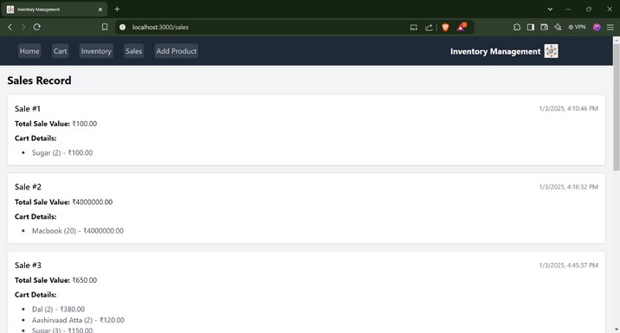

**Add Product:**

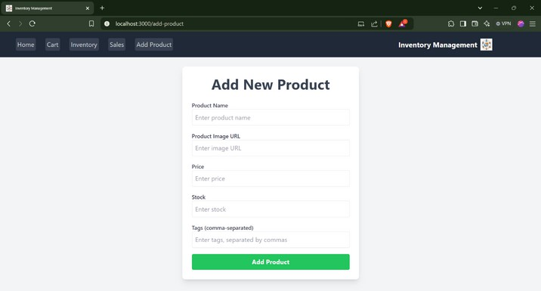

**\*\*\*Thank You\*\*\***